AGILE SPRINT PLANNING &
USER STORY WORKSHOP REPORT
Software Engineering — CO1 Assessment (AT-2)
AI-Based Road Surface Damage Detection and Maintenance Planning System

Name: | DEVI VARA PRASAD
Register No.: | 192365032
Institution: | Saveetha School of Engineering, SIMATS
Course: | Software Engineering
Assignment: | Agile Sprint Planning & User Story Workshops (CO1_AT-2)
Problem No.: | 17 — AI-Based Road Surface Damage Detection and Maintenance Planning System
Date: | 24 July 2026

1. Project Vision and Stakeholders

1.1 Project Vision
To build an AI-powered platform that automatically detects, classifies, and maps road surface defects from camera and drone imagery, enabling municipal authorities to move from slow, manual road inspection to fast, data-driven, predictive maintenance planning — improving road safety while cutting inspection and repair costs.

1.2 Project Objectives
- Automate detection and classification of potholes and pavement cracks from images.
- Estimate defect severity and visualise it on a GIS-based map.
- Generate prioritised, data-driven maintenance schedules for repair crews.
- Deliver a working product increment every sprint through Agile/Scrum practice.

1.3 Key Stakeholders
Table 1: Key Stakeholders and Their Roles
Stakeholder | Role in the Project
Municipal / Highway Authority | Product owner-side sponsor; defines priorities, approves releases, and funds the project.
Road Maintenance Contractors | End users of the maintenance schedule; consume prioritised repair lists generated by the system.
Drone / Camera Field Operators | Supply raw image and video data that feeds the AI detection pipeline.
Scrum Team (Developers, AI Engineers, QA) | Design, build, test, and iteratively deliver the product increment each sprint.
Scrum Master | Facilitates ceremonies, removes blockers, and coaches the team on Agile practice.
Product Owner | Owns and prioritises the product backlog on behalf of the municipal authority.
GIS Analysts / Data Scientists | Provide domain input on mapping accuracy and validate AI severity-scoring outputs.
Citizens / Commuters | Indirect beneficiaries; safer, better-maintained roads and (optionally) a defect-reporting channel.

2. Epics and User Stories
The product backlog has been broken down into seven Epics, each covering one major functional area of the system. Representative user stories are written in the standard Agile format below.

Epic 1: Image Acquisition & Upload
"As a drone operator, I want to upload captured road images directly from the field app, so that inspection data reaches the system without delay."
"As a field inspector, I want the app to auto-tag each image with GPS coordinates and timestamp, so that defects can be located accurately later."

Epic 2: AI Defect Detection & Classification
"As a system administrator, I want the platform to automatically detect potholes and cracks in uploaded images, so that manual visual inspection is no longer required."
"As a maintenance planner, I want each defect classified by type (pothole, longitudinal crack, alligator crack), so that I can plan the right repair method."

Epic 3: Severity Estimation
"As a maintenance planner, I want each detected defect to receive a severity score (minor/moderate/severe), so that I can judge urgency at a glance."

Epic 4: GIS Mapping & Visualisation
"As a municipal engineer, I want to view all detected defects plotted on a city map, so that I can see problem areas geographically."

Epic 5: Maintenance Prioritisation & Scheduling
"As a maintenance planner, I want the system to automatically rank defects by severity and road importance, so that repair crews are sent to the most urgent locations first."

Epic 6: Reporting & Analytics Dashboard
"As a municipal authority official, I want a dashboard summarising road health citywide, so that I can report infrastructure status to leadership."

Epic 7: User & Access Management
"As a system administrator, I want to control which users can upload data, view maps, or approve schedules, so that the platform stays secure and well governed."

3. Acceptance Criteria
Clear, testable acceptance criteria have been written for the highest-priority user stories using the Given–When–Then format, ensuring the development team and product owner share the same definition of "done" for each story.
Table 2: Acceptance Criteria for Key User Stories
ID | User Story (short) | Given | When | Then
US-01 | Upload image from field app | Given the operator is logged in and has a captured photo | When they tap "Upload" | Then the image is stored with GPS + timestamp metadata within 5 seconds
US-03 | Auto-detect potholes/cracks | Given an uploaded image contains a road surface | When the AI pipeline processes the image | Then detected defects are outlined with type labels and a confidence score
US-05 | Assign severity score | Given a defect has been detected and classified | When the severity module analyses size and shape | Then a severity level (minor/moderate/severe) is attached to the defect record
US-07 | View defects on GIS map | Given defects exist in the database with GPS data | When the engineer opens the map dashboard | Then all defects appear as colour-coded pins matching their severity
US-09 | Auto-prioritise repairs | Given multiple defects exist across several roads | When the scheduling module runs its ranking algorithm | Then a sorted repair list is generated with severe defects ranked first
US-12 | View city-wide health dashboard | Given defect and repair data exists for the reporting period | When the official opens the analytics dashboard | Then summary charts of defect counts, severity mix, and repair status are displayed

4. Prioritize the Product Backlog
The backlog was prioritised using a Value-vs-Effort matrix (Figure 1), which plots each epic by the business value it delivers against the implementation effort it requires. Epics falling in the "Quick Wins" and "Major Projects" quadrants — image acquisition, AI detection, and severity estimation — were assigned the highest priority (P1) because they form the technical foundation the rest of the system depends on.
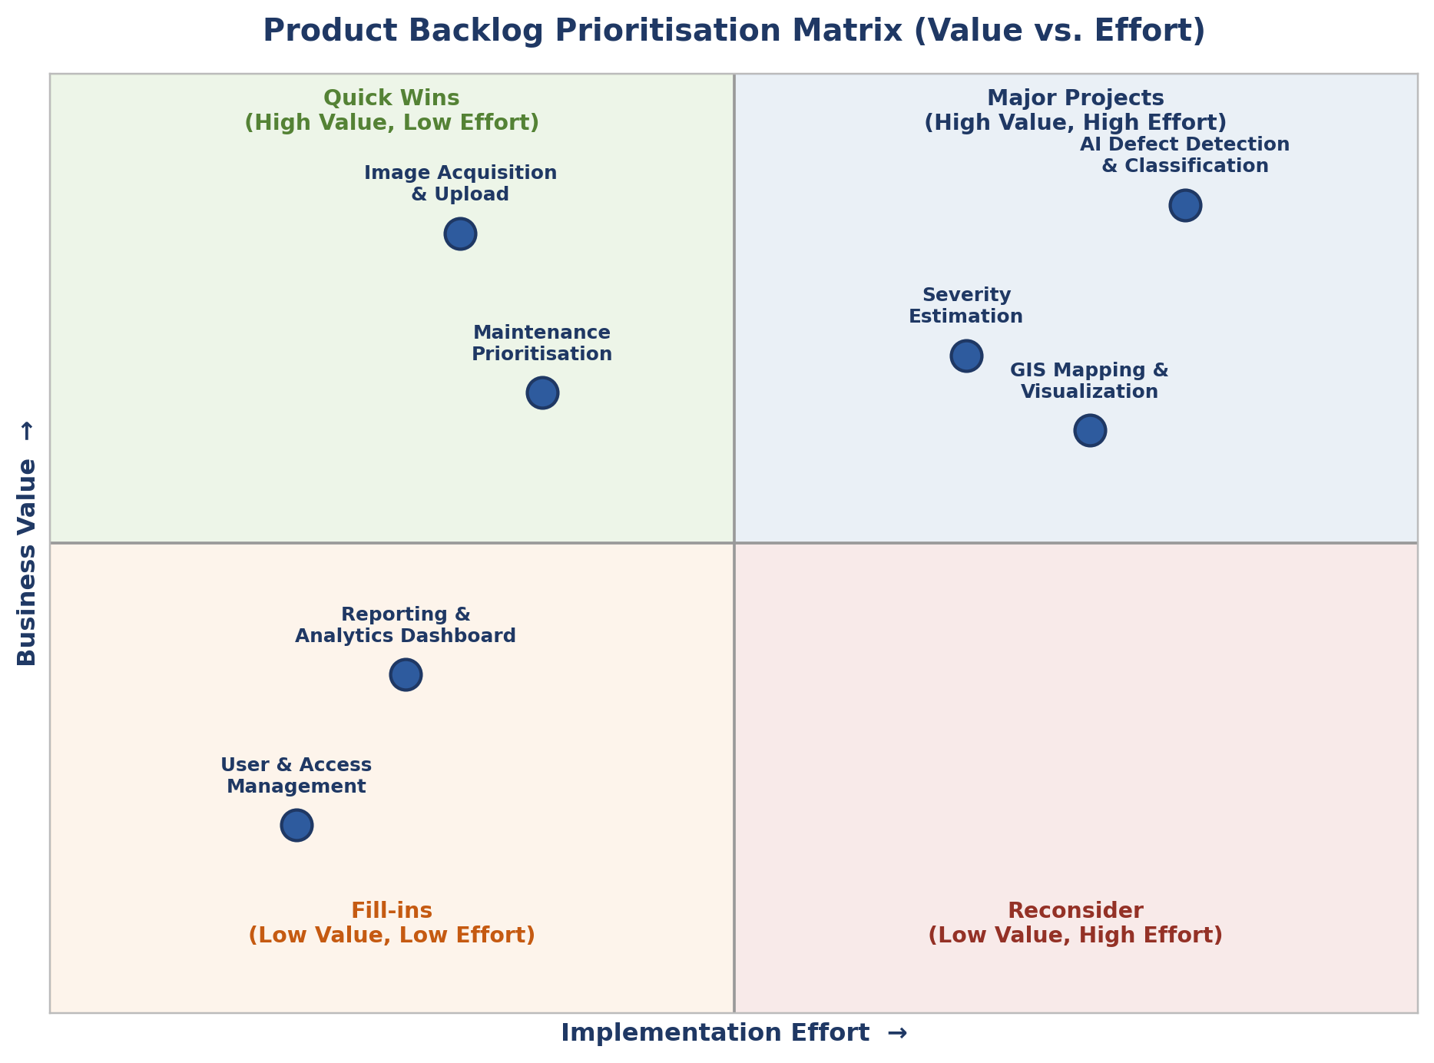
Figure 1: Value-vs-effort prioritisation matrix used to rank epics in the backlog.
Table 3: Prioritised Product Backlog
ID | User Story | Business Value | Priority | Dependency
US-01 | Upload image from field app with GPS/timestamp | High | P1 | None
US-02 | Preprocess/enhance uploaded images | Medium | P2 | US-01
US-03 | Auto-detect potholes/cracks (AI) | High | P1 | US-01, US-02
US-04 | Classify defect type | High | P1 | US-03
US-05 | Assign severity score | High | P1 | US-04
US-06 | Store defect records centrally | Medium | P2 | US-05
US-07 | View defects on GIS map | High | P2 | US-06
US-08 | Filter map by severity/road/date | Medium | P3 | US-07
US-09 | Auto-prioritise repair list | High | P2 | US-05, US-06
US-10 | Export maintenance schedule | Medium | P3 | US-09
US-11 | Field crew mobile view of assigned repairs | Medium | P3 | US-09
US-12 | City-wide analytics dashboard | Medium | P3 | US-06
US-13 | Role-based access control | Medium | P2 | None

5. Plan the Sprint Backlog
For Sprint 1 (a two-week sprint), the team selected the five highest-priority, most foundational stories from the backlog — those the rest of the system depends on. Each story was broken down into concrete development tasks, shown below and tracked on the Sprint 1 board (Figure 2).
Table 4: Sprint 1 Backlog — Selected Stories and Development Tasks
User Story | Development Tasks
US-01: Upload image from field app | 1. Build mobile/web upload UI 2. Implement GPS + timestamp tagging 3. Create secure upload API endpoint 4. Write unit tests for upload flow
US-02: Preprocess uploaded images | 1. Implement image resize/normalise pipeline 2. Add noise/blur filtering 3. Validate output on sample dataset
US-03: Auto-detect potholes/cracks | 1. Prepare labelled training dataset 2. Train CNN/YOLO detection model 3. Deploy model as an inference service 4. Integrate with upload pipeline
US-04: Classify defect type | 1. Extend model output to defect-type labels 2. Validate classification accuracy 3. Store type in defect record schema
US-13: Role-based access control | 1. Design roles (admin, planner, field crew) 2. Implement authentication/authorisation 3. Test access restrictions per role

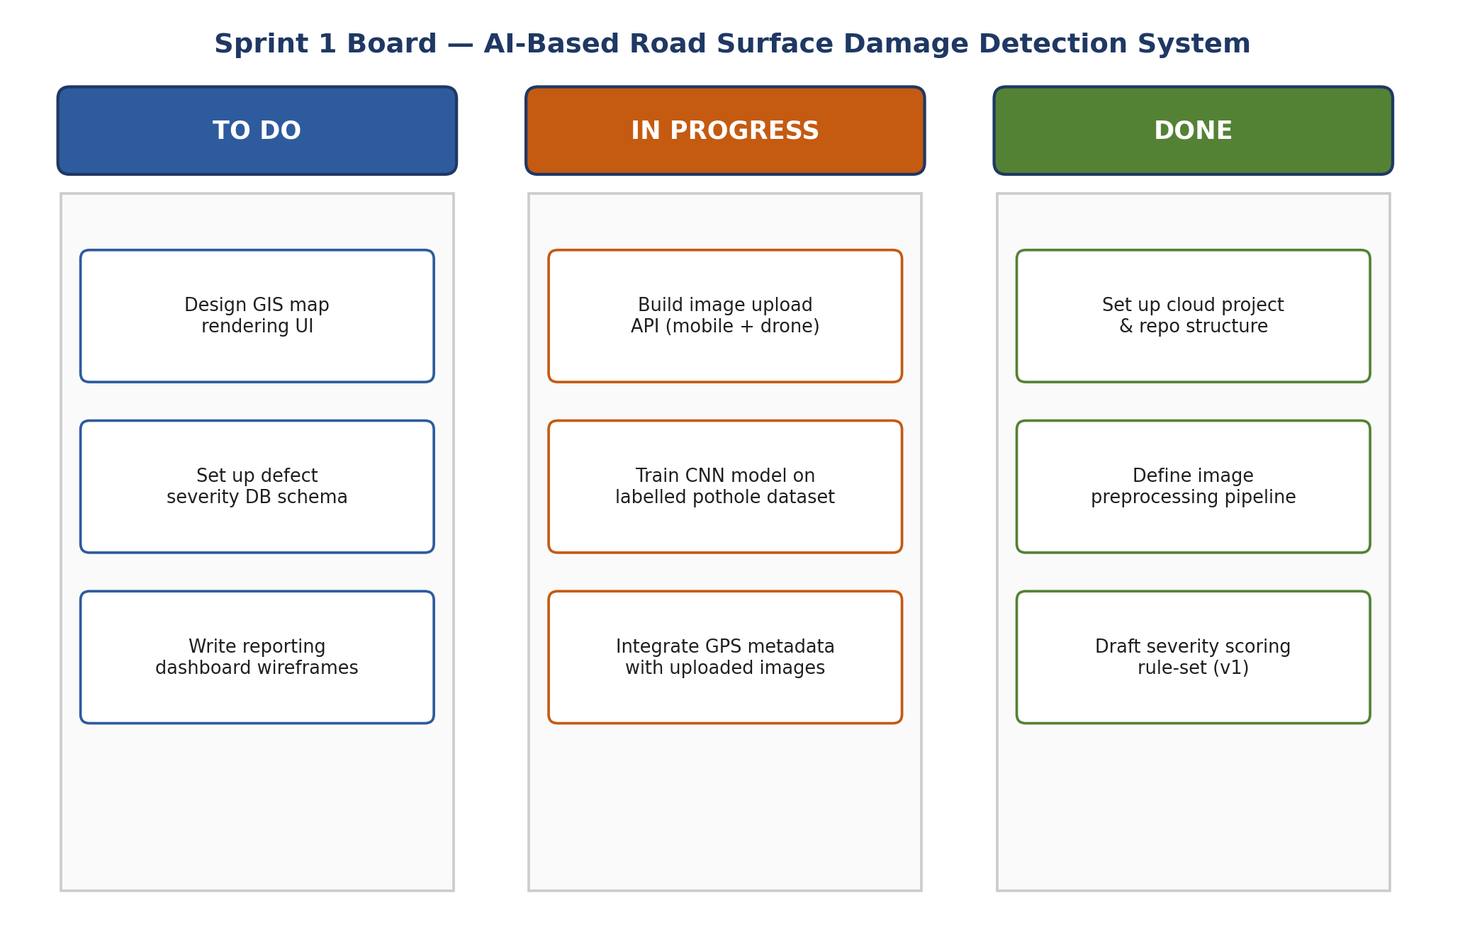
Figure 2: Sprint 1 Kanban board showing task flow across To Do, In Progress, and Done.

6. Estimate Effort Using Story Points
Story points were assigned using Planning Poker with the Fibonacci sequence (1, 2, 3, 5, 8, 13...), where each number reflects relative complexity, effort, and uncertainty rather than exact hours. The whole Scrum team estimated independently and discussed any large gaps before converging on a final value for each story.
Table 5: Story Point Estimates for Sprint 1 Backlog
User Story | Story Points (Fibonacci) | Justification
US-01: Upload image from field app | 3 | Standard CRUD + file-upload work with GPS tagging; moderate complexity, well-understood pattern.
US-02: Preprocess uploaded images | 2 | Small, self-contained image-processing utility with limited edge cases.
US-03: Auto-detect potholes/cracks | 8 | Requires dataset preparation, model training, and inference deployment — high complexity and uncertainty.
US-04: Classify defect type | 5 | Builds on the detection model but adds new output classes and validation effort.
US-13: Role-based access control | 3 | Well-understood authentication pattern, but needs careful testing across multiple roles.
The Sprint 1 backlog totals 21 story points. This is consistent with the team's estimated velocity of approximately 20–24 points per two-week sprint, based on team size and comparable past project experience, and leaves a small buffer for unplanned work or bug fixes discovered during the sprint.

7. Present the Sprint Goal and Expected Deliverables

7.1 Sprint Goal
By the end of Sprint 1, field operators can upload road images through a working mobile/web interface, and the AI pipeline can automatically detect and classify road defects from those images — establishing the core data pipeline that every later feature (severity scoring, GIS mapping, and scheduling) will build on.

7.2 Expected Sprint Deliverables
- A working image upload interface with automatic GPS and timestamp tagging (US-01).
- An image preprocessing pipeline that cleans and normalises uploaded photos (US-02).
- A trained and deployed AI model capable of detecting potholes and cracks in road images (US-03).
- Defect-type classification integrated into the detection pipeline (US-04).
- Role-based access control distinguishing administrators, planners, and field crew (US-13).
- A short sprint review demo showing an end-to-end flow: image upload → detection → classified defect record.

7.3 Definition of Done for the Sprint
A story is considered done when its code is reviewed and merged, unit tests pass, the feature has been demonstrated to the Product Owner in the sprint review, and its acceptance criteria (Section 3) are fully satisfied.

